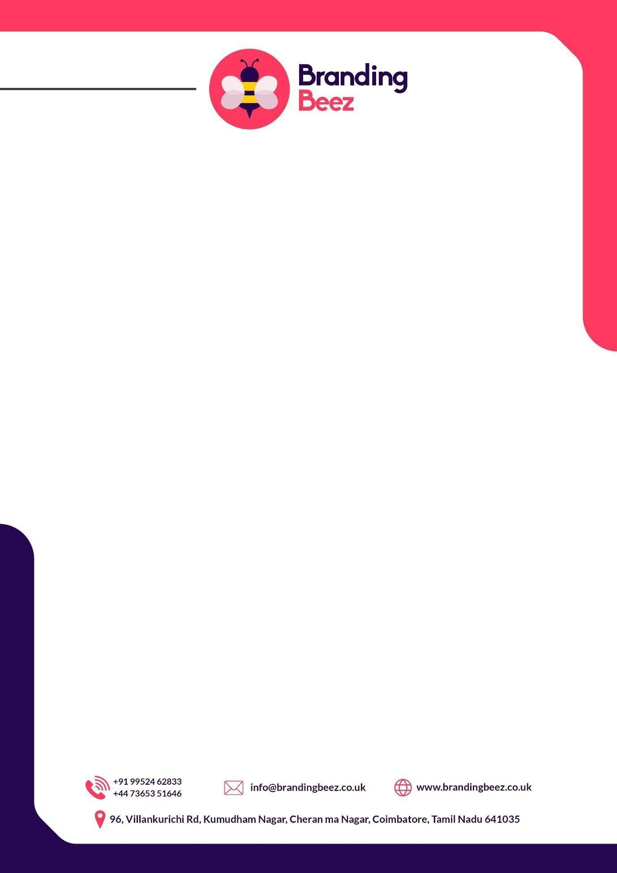

Appointment Letter

**Date:** 30/08/25

**Place:** Coimbatore

# Dear Satheshkumar,

We are delighted to extend an offer for the position of **Full Stack Executive at BrandingBeez.**We have carefully reviewed your qualifications and believe that you will be a valuable asset to our organization.

Please review the following details of your employment:

**Position:** Full Stack Executive

## Starting Date: 01/09/2025

**Base salary:** INR 5,16,000 per annum (paid monthly by direct deposit)

# Salary and Compensation:

Your monthly Cost to Company (CTC) will be INR 43,000 per month. There will be a probation of 3 months. The probation period is intended for you to learn the work process, understand the company culture, and develop effective client communication and client relationship skills and the below listed performance parameters in probation policy. Once your performance meets the required expectations, you will be offered permanent employment and your salary will be revised to **INR 45,000 per month**. Salary payments will be processed on 10th of each month, ensuring timely remuneration for your dedicated efforts. After successfully completing your probation period, you will receive an updated offer letter with a revised fixed salary reflecting your confirmed employment status.



# Working Hours:

Your work schedule will follow a five-day week from Monday to Friday, with alternate Saturdays also considered working days. This means you will work every other Saturday, depending on the schedule. Shift timings may vary based on project requirements. and any such changes will be announced at least two weeks in advance by your manager or HR. Each working day will include a total of 8 working hours, excluding a daily one-hour break, which is provided to support a healthy work life balance. The break is not counted as part of the 8 working hours, so your total time at work each day will typically be around 9 hours. The standard work week generally runs from Monday to Saturday, depending on the alternate Saturday rotation.

# Work From Home Policy:

Work From Home is not permitted under any circumstances. If you are unwell or face any personal issue that prevents you from working, you can apply for leave. WFH is not allowed during probation, notice period, or confirmed employment. Any violation of this policy will be considered misconduct and may invite disciplinary action.

# Client Work Policy:

Employees are strictly prohibited from utilizing or appropriating client work, whether during their tenure or after leaving the company. Employees must not disclose or use the company's logo or any products they work on or have worked on for another client, nor should these be sold or altered for another client. The company reserves the right to claim patent rights on its products. This policy ensures the integrity and confidentiality of client projects and information.



# Client Relationship:

The employees should maintain a good relationship with the client to build up trust. They can approach the client in accordance with the company's directions, ensuring that they act in a trustworthy manner. Demonstrating professionalism and a proactive approach in understanding and fulfilling client requirements is essential. Building long-term partnerships through consistent delivery of quality service and fostering a collaborative and respectful atmosphere to maintain positive client relationships.

# Employee Relationship:

The employee maintains relationships with proper respect for every individual, ensuring interactions are conducted with dignity and professionalism. They are to refrain from using offensive language, fostering an environment of mutual respect and understanding. By upholding these standards, the employee contributes to a harmonious workplace where all individuals feel valued and respected. Such conduct enhances teamwork and promotes a positive work culture.

# Probation:

You will be placed on a probation period of three months from the date of appointment. At the end of this period, a review meeting will be conducted with your Manager and the HR Department to evaluate your performance. The review will be based on the following key parameters:

* **Project Delivery** – Quality, timeliness, and ownership of work.
* **Technical Skills** – Problem-solving, coding standards, and innovation.
* **Team Collaboration** – Support to juniors and coordination with the team.
* **Client Communication** – Professionalism and relationship management.
* **Discipline & Policy Adherence** – Attendance, punctuality, and compliance with company policies.
* **Future Readiness** – Ability to take on higher responsibilities.



Based on the outcome of this review, your employment will be confirmed in writing, and your salary will be revised in accordance with company policy. In exceptional cases, if your performance should be improved, the probation period may be extended.

## Absences and Exit Policy:

As an employee, you are not entitled to any absences during your probation and notice periods. Once you become a permanent employee of the organization, you will be entitled to 12 days of Casual paid time off and one Sick Absence per month on a yearly calendar basis. The detailed absence policy is mentioned in Annexure 1: Absence Policy. We encourage you to utilize these absences responsibly and in accordance with our company policies.

In the event that you decide to resign from the organization, we appreciate your commitment to providing prior notice and serving **90 working days** of the notice period. This will allow us to make the necessary arrangements and ensure a smooth transition.

# Leave Request Policy:

All leave requests must be submitted via email to your reporting manager at least 14 days in advance, and such requests will be considered valid only upon receiving formal approval. Requests made through chat messages, phone calls, or verbal communication will not be accepted under any circumstances, as the company requires written documentation for proper tracking and planning. In case of emergencies such as sudden illness or urgent family matters, employees must inform their manager immediately by phone or message; however, a formal email request must still be submitted within 24 hours to maintain proper records.



# Increments:

We value your hard work and dedication to the company. Salary increments are reviewed on an annual basis and are based on your performance, the company's financial status, and industry standards. Outstanding performance will be rewarded with increments, bonuses, or other forms of recognition. Your first salary review will be conducted at the end of your probation period, and subsequent reviews will occur annually.

# Safety and Well-Being Policy:

Your well-being is very important to us. We are dedicated to ensuring a supportive work environment and prioritize your health and safety at all times. The safety policy will be mentioned in Annexure:1. If you ever feel uncomfortable or unsafe in the work environment, please do not hesitate to contact Mr. Vigneshwaran at +91 9952462833.

# Code of Conduct and Behavior:

All employees are expected to maintain a professional, respectful, and responsible attitude in the workplace. This includes:

* Using polite and professional language at all times in verbal or written communication.
* Demonstrating punctuality and sincerity in performing assigned duties.
* Collaborating effectively with colleagues to maintain a positive team environment.
* Dressing in a professional manner. Indecent, casual, or inappropriate clothing (such as ripped jeans, sleeveless vests, or overly casual wear) will not be permitted in the workplace

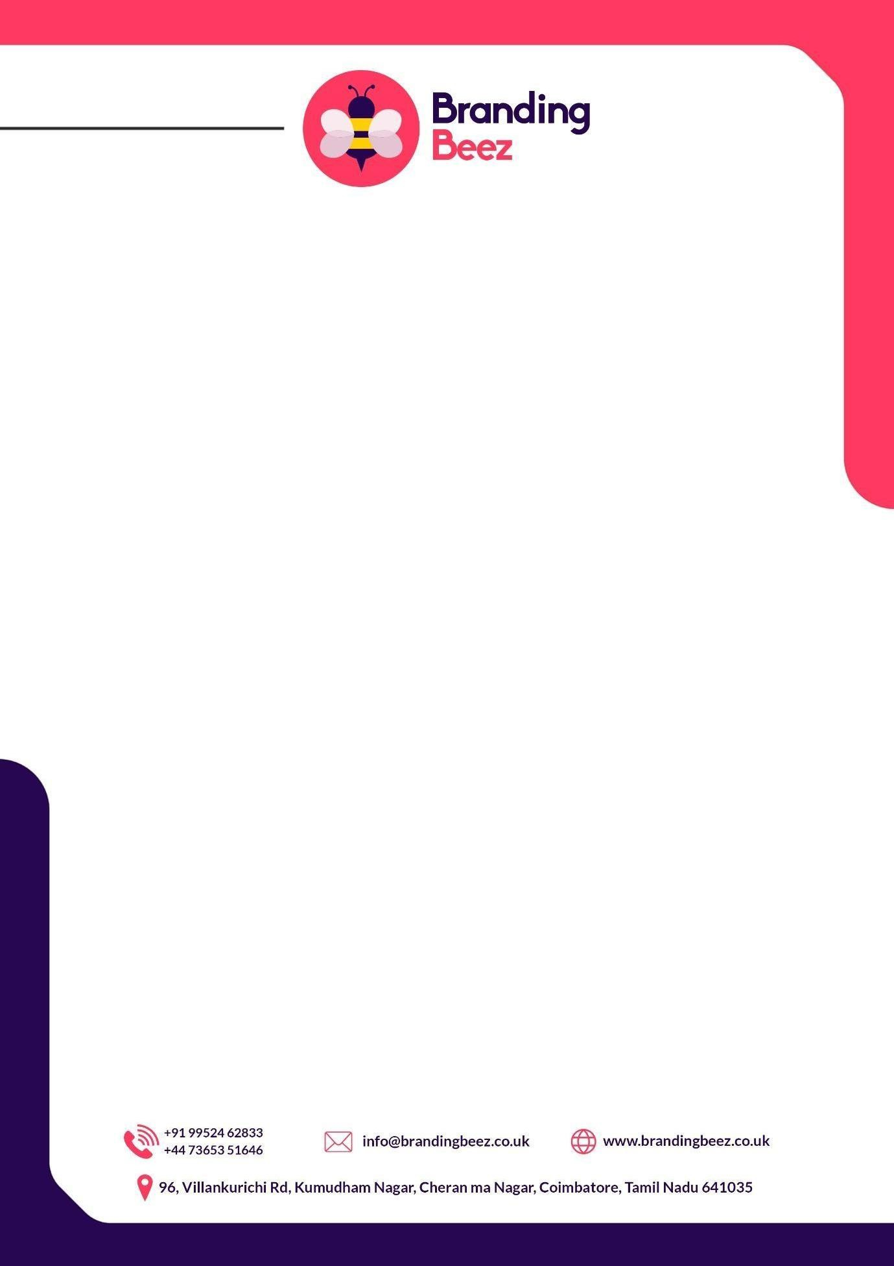

# Confidentiality Policies:

At BrandingBeez, we place great importance on maintaining the confidentiality of our work. Therefore, we kindly request that you adhere to the following policies:

During work hours, your primary focus should be on tasks related to BrandingBeez and any affiliated firms. Personal or other business activities should not be conducted during this time.

1. Safeguarding all passwords and credentials associated with BrandingBeez is crucial. Sharing such information is strictly prohibited. Any misuse or unauthorized disclosure will result in a thorough investigation and may lead to legal actions, subject to Coimbatore jurisdiction, Tamil Nadu.
2. All work produced during your tenure at BrandingBeez will be the property of the company. We reserve the right to change or modify any work as needed. When representing BrandingBeez, whether internally or externally, please use the provided email ID for all communication. Remember to keep your email credentials secure at all times.
3. It is essential to exercise caution with regard to opening emails containing suspicious links. Opening such emails without consulting a higher authority may result in termination.
4. We hope that these terms and conditions are satisfactory to you. If you have any questions or require further clarification, please do not hesitate to contact us at [info@brandingbeez.co.uk](mailto:info@brandingbeez.co.uk) or 7871990263.

# Termination Policy:

1. BrandingBeez expects all employees to maintain discipline, respect, and professionalism at work and during external interactions. Violation of these standards, company policies, or engagement in misconduct will result in the following termination actions:
2. For minor offenses, a warning will be issued for each instance of indiscipline or rudeness. Upon the third warning, employment will be terminated immediately.

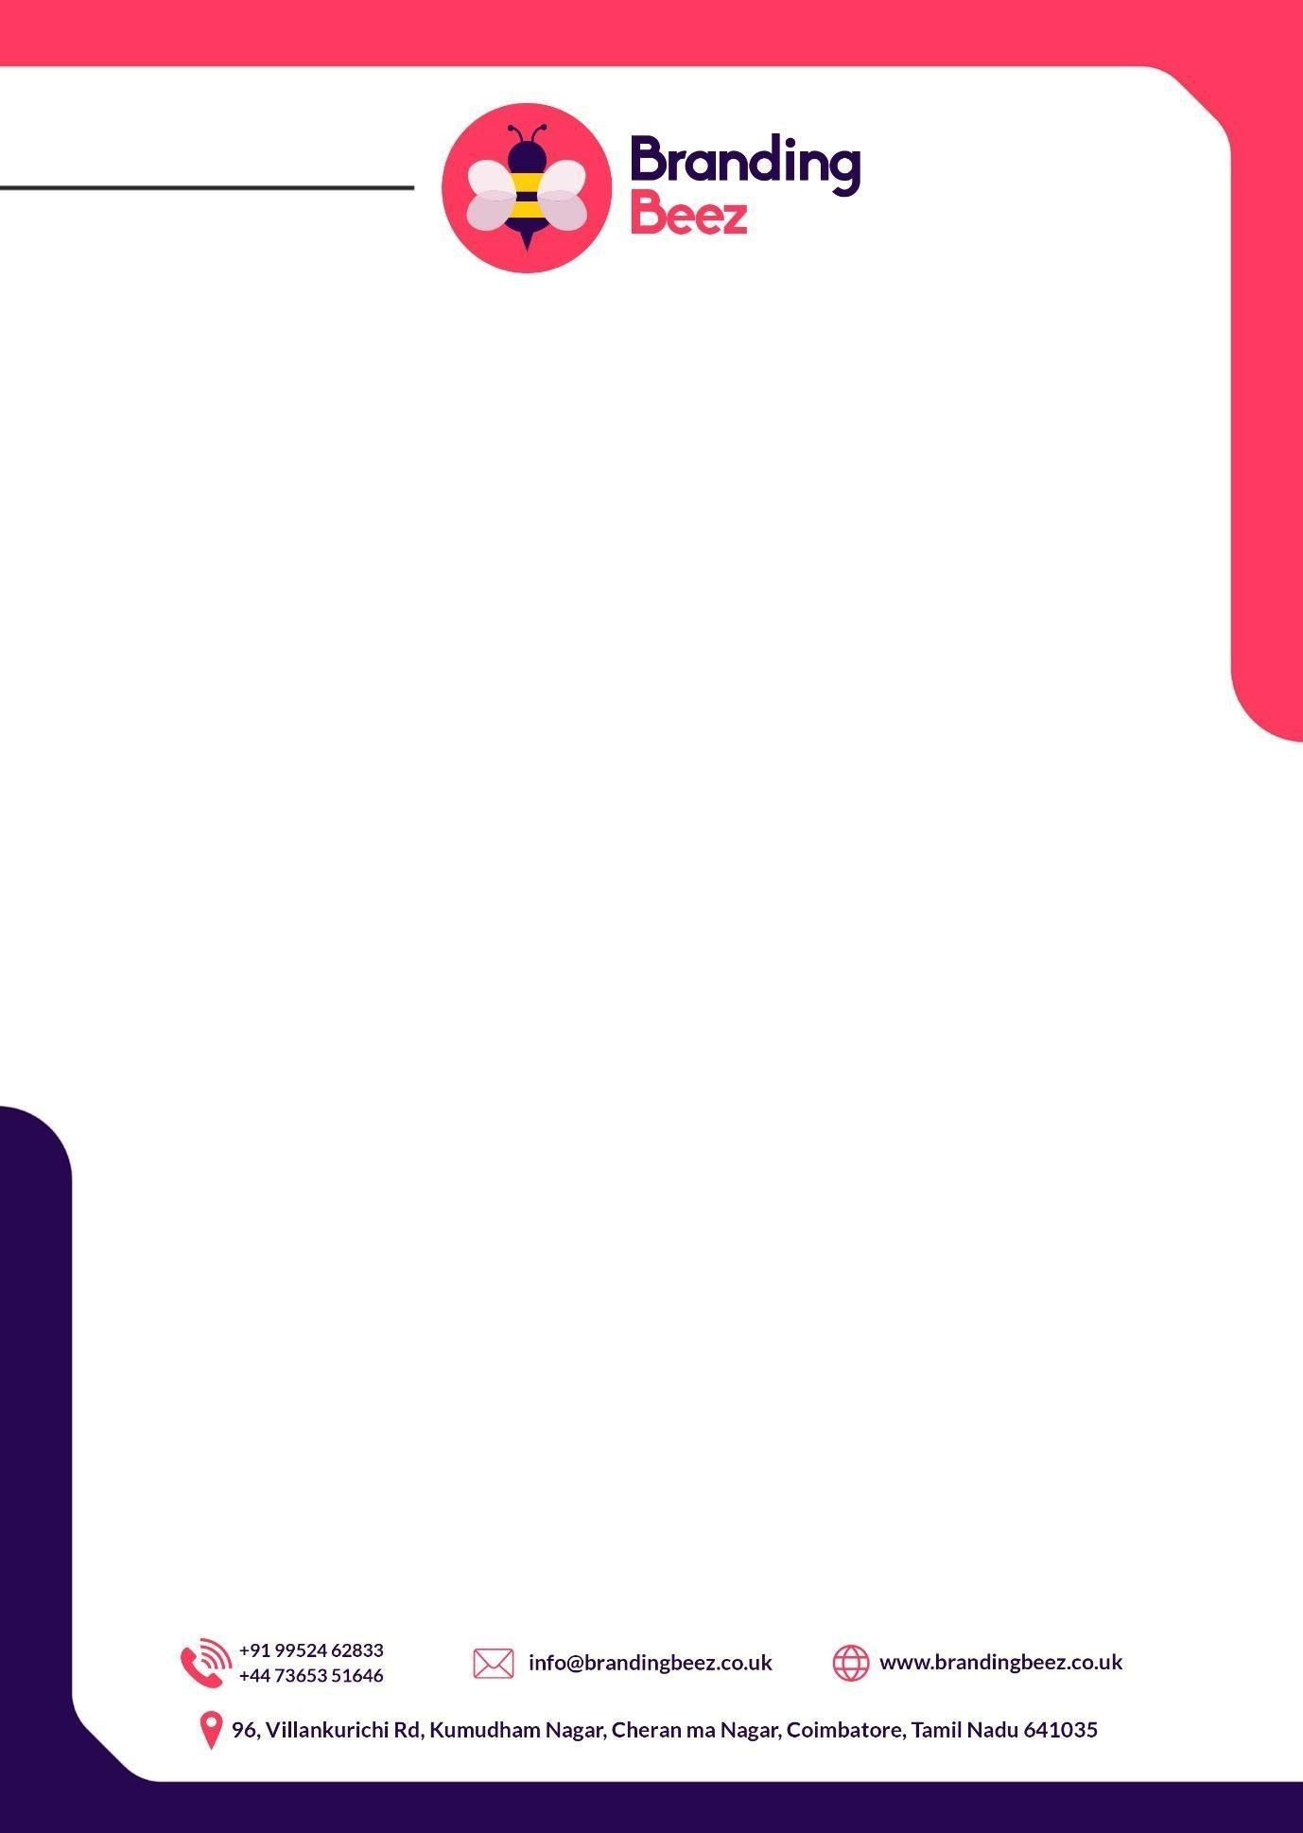

1. BrandingBeez expects all employees to maintain discipline, respect, and professionalism at work and during external interactions. Violation of these standards, company policies, or engagement in misconduct will result in the following termination actions:
2. For minor offenses, a warning will be issued for each instance of indiscipline or rudeness. Upon the third warning, employment will be terminated immediately.
3. For serious disciplinary violations or misconduct, the company reserves the right to terminate employment without notice and without salary for the notice period. All dues till the last working day will be settled as per law through the Final Acceptance and Release Agreement (FARA).
4. For business reasons such as project closure or organizational needs, the company will provide a 15-day notice period. The employee must serve this notice, and salary will be paid for days worked in the notice period. FARA must be completed for final settlement.

Failure to adhere to company rules and policies may lead to termination at the company’s discretion at any time.

# Absconding Policy:

Absconding during the notice period is treated as a serious breach of contract and company policy. In such cases, the company reserves the right to withhold or forfeit any payable dues, including the salary for the notice period and also previous month salary or any pending final settlements, except as mandated by applicable law. Furthermore, the employee will not be issued relieving, experience, or any other employment-related letters. The company may also record the separation as absconding in their records and reserve the right to share this information with background verification agencies or pursue legal action if necessary. This policy ensures organizational protection and enforces adherence to the notice period terms.



**Note :** Please note that all the above-mentioned policies, terms, and conditions are subject to change, amendment, or withdrawal at the sole discretion of the management, without prior notice. Any such modifications may be carried out to meet the evolving business requirements, operational priorities, or statutory compliance needs of the Company. Employees are required to adhere to the updated policies as and when communicated by the management. It is important to understand that the Company reserves this right to ensure alignment with its business goals and organizational interests.

If the employee fails to follow the above-mentioned rules and regulations, he/she will be terminated at the discretion of the company.

To accept this offer, please sign and return a copy of this letter

We look forward to welcoming you to the BrandingBeez team and working together to achieve great success.

If you choose to accept this job offer, please sign and return this letter at your earliest convenience by 30/8/25 Once your acceptance has been received, we will send you information about onboarding and other asset details.

# Congratulation! We look forward to working with you Date:30/08/25 Authorized Signature,

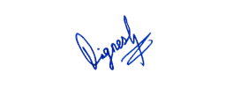

**Vigneshwaran Veluswamy**

**Place: Coimbatore**



# Letter of Acceptance (To be filled by the Employee)

## Dear Sir/Madam,

I **Satheshkumar.V** accept the appointment offered in your letter, in accordance with the attached terms and conditions for the position of **Full Stack Executive** in BrandingBeez.

I understand, and agree to abide by, my obligations under these conditions. I also agree to abide by all other instructions as may be issued from time to time by the CEO or the directors of BrandingBeez.

Date: 30/08/2025

Name: Satheshkumar V

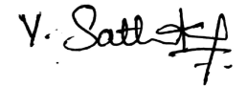Place: Coimbatore

Signed: